Modul Number: 0750362
Module Name: Database Applications

Teacher: Eman Alnaji

Part I
Revision of Database Concepts

Basic Definitions:
- Data: Known facts that can be recorded and have an implicit meaning.
- Database : A collection of related data
- Database management system (DBMS): A collection of computer programs, which enables users to create and maintain databases.
- Schema: description of data at some level (e.g., tables, attributes, constraints, domains)
A Relation:
Relation is a set of tuples/records
  - Tuple ordering irrelevant
  - Cardinality of relation = number of tuples
- All tuples in a relation have the same structure; constructed from the same set of attributes
  - Attributes named (=> ordering irrelevant)
  - Value of an attribute drawn from the attribute’s domain

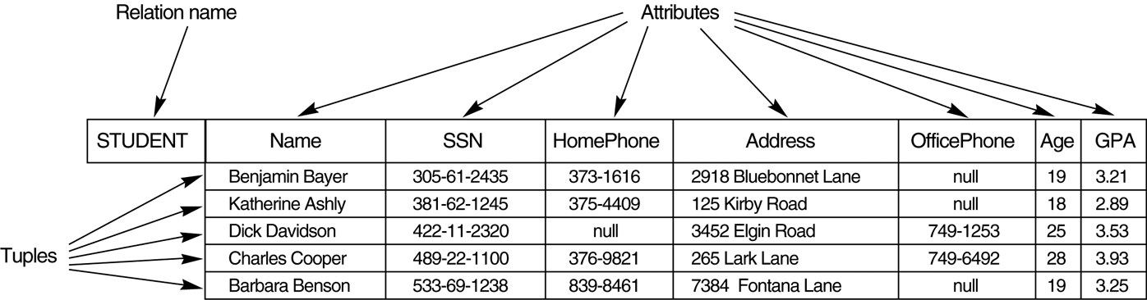
Figure 1: Student Relation.

Relation as A Table
Relation Table
Tuple Row
Attribute Column
Relational Database Management System (RDBMS)
- Finite set of relations
- Database schema = set of relations (and other things)

Database Schema (Example):
- Student (Id: INT, Name: STRING, Address: STRING, Status: STRING)
- Professor (Id: INT, Name: STRING, DeptId: DEPTS)
- Course (DeptId: DEPTS, CrsName: STRING, CrsCode: COURSES)
- Transcript (CrsCode: COURSES, StudId: INT, Grade: GRADES, Semester: SEMESTERS)
- Department(DeptId: DEPTS, Name: STRING)

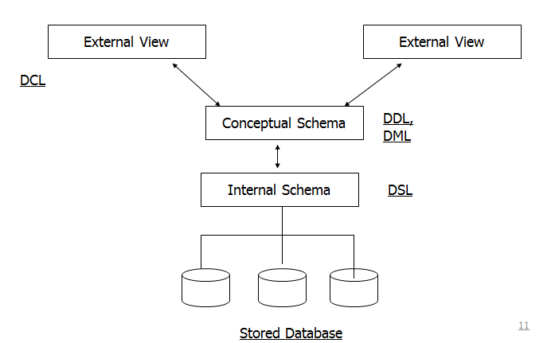
Figure2: Three-schema Architecture of an RDBMS.
DDL: Data Definition Language
Used by DBAs or designers to define schema
(CREATE, DROP, ALTER)
DML: Data Manipulation Language
Used to insert, update and delete data in database tables.
(INSERT, UPDATE, DELETE, SELECT)
DCL: Data Control Language
Used to create roles, permissions, and referential integrity and to control access on a database.
(GRANT, REVOKE)
DSL: Data Storage Language
Specifies Internal Schema (used by the RDBMS)
TCL: Transactional Control Language
Used to manage different transactions occurring within a database.
(COMMIT, ROLLBACK)

Integrity Constraints
- Part of schema
- Restriction on state (or sequence of states) of database
- Enforced by DBMS
Database Integrity
Implies that the data held in the tables of the database is consistent in terms of the Relational Data Model
- Two Types
  - Entity integrity (PK)
  - Referential Integrity (FK)
Relation Keys Constraints
- Key Constraint: Values in a column (or columns) of a relation are unique: at most one row in a relation instance can contain a particular value(s)

- What is a Key?
  - A minimal set of attributes satisfying key constraint
- Every relation has a key
- Candidate Key-
  - No two tuples of the relation will have identical entries in all attributes of the key.
  - The number of attributes that comprises the key must be minimal.
- Primary Key- Since a table may have more than one candidate key, one should be designated as the primary key (PK) of the relation.
Examples:
  - primary key (Id in Student) –
  - candidate key ((Name, Address) in Student)
- A RDBMS allows only one primary key per table.
  - Once a PK has been selected, any remaining candidate keys are called alternate keys.
- A primary key may be composed of
  - a single attribute (single primary key)
    - E.g. ID
  - More than one attribute (composite primary key)
    - E.g. Code + Serial
- An attribute that is a primary key can not have a null value
- An attribute that is part of any key is called a prime attribute.
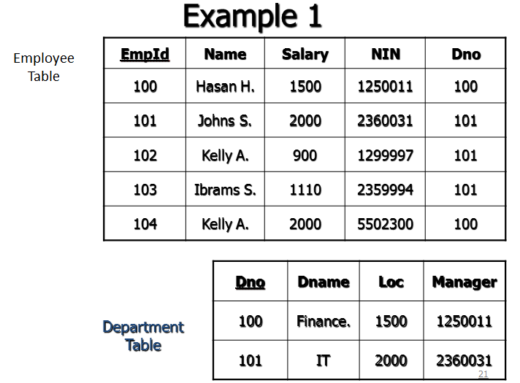
Figure3: Example of Primary Key

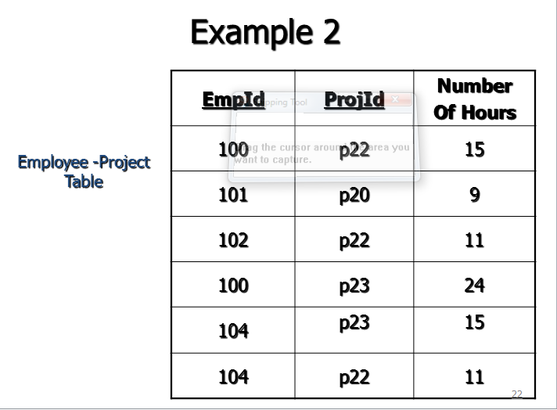
Figure4: Example of Composite Key
- Primary keys are
  - defined using Data Definition Language (DDL)
  - Automatically enforced by the RDBMS
  - Generally are defined at the time the tables are created.
- When selecting primary keys, we need to choose attributes that satisfy the uniqueness and minimalist conditions for all permissible data.
NULL
- What is NULL?
  - a NULL value is used to represent missing information, unknown, or inapplicable data.
  - A NULL value is not a zero value
  - A NULL value doesn’t represent a particular value within the computer.
Foreign Key Constraint
- Referential integrity => Item named for primary key attribute/s in one relation must correspond to tuple(s) in another that describes the item
  - Employee (ProjId) references Project(ProjId)
  - Professor(DeptId) references Department(DeptId)
- a1 is a foreign key of R1 referring to a2 in R2 => if v is a value of a1, there is a unique tuple of R2 in which a2 has value v
  - This is a special case of referential integrity: a2 must be a candidate key of R2 (DeptId is a key of Department)
  - If no row exists in R2 => violation of referential integrity
  - Not all rows of R2 need to be referenced: relationship is not symmetric
  - Value of a foreign key might not be specified (DeptId column of some professor might be null)
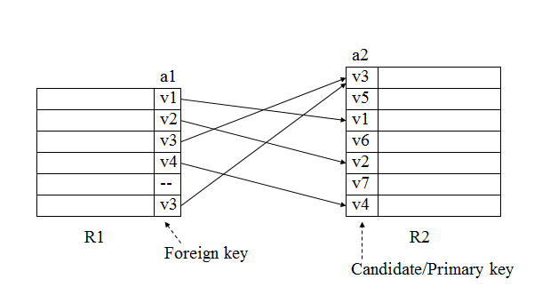
Figure5: Example of Foreign key constraint
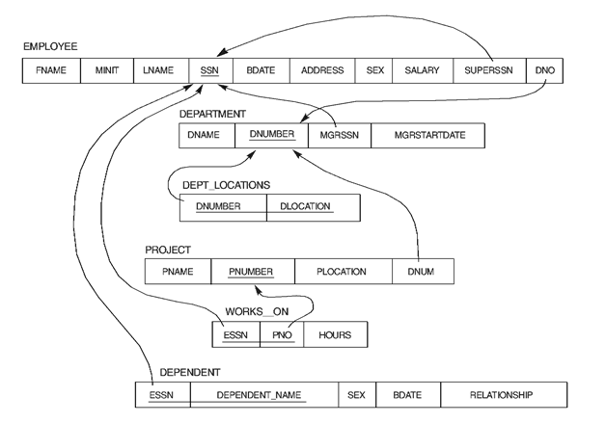
Figure6: Company Database (Foreign key constraints)
- Names of a1 and a2 need not be the same.
  - With SQL tables:
Foreign key <name> professor (DeptId) references
Department (Dno)
DeptId attribute of Professor Table references to Dno attribute in
Department Table
- R1 and R2 need not be distinct.
- The attributes of where the referential integrity exists must have the same data type and length.
- Foreign key might consist of several columns
  - (CrsCode, Semester) of Transcript references (CrsCode, Sem) of Teaching
- R1(a1, …an) references R2(b1, …bn)
  - There exists a 1 - 1 relationship between a1,…an and b1,…bn
  - ai and bi have same domains (although not necessarily the same names)
  - For every tuple T in R1 over ai’s there exists a unique tuple S in R2 over bi’s, with T = S
  - b1,…bn is a candidate key of R2
Semantic Constraints
- Domain, primary key, and foreign key are examples of structural (syntactic) constraints
- Semantic constraints express rules of application:
  - e.g., number of registered students ≤ maximum enrollment
  - SQL calls them Check constraint

